 | Abdi İpekçi Caddesi Kaşıkçıoğlu Apt.  No:42/2 34365 Nişantaşı İstanbul  www.artxist.com info@artxist.com  T. +90 212 291 77 84 F. +90 212 343 69 35 | PRESS RELEASE

x-ist @ Art 14 London – Stand No: G11

In Art 14 London, the established İstanbul-based gallery x-ist will showcase brand new works from a selection of the best of established and emerging Turkish artists including Ceren Oykut, Erkut Terliksiz, Ansen, Serkan Adın, Burçin Başar, Ali Elmacı and Bahadır Baruter.

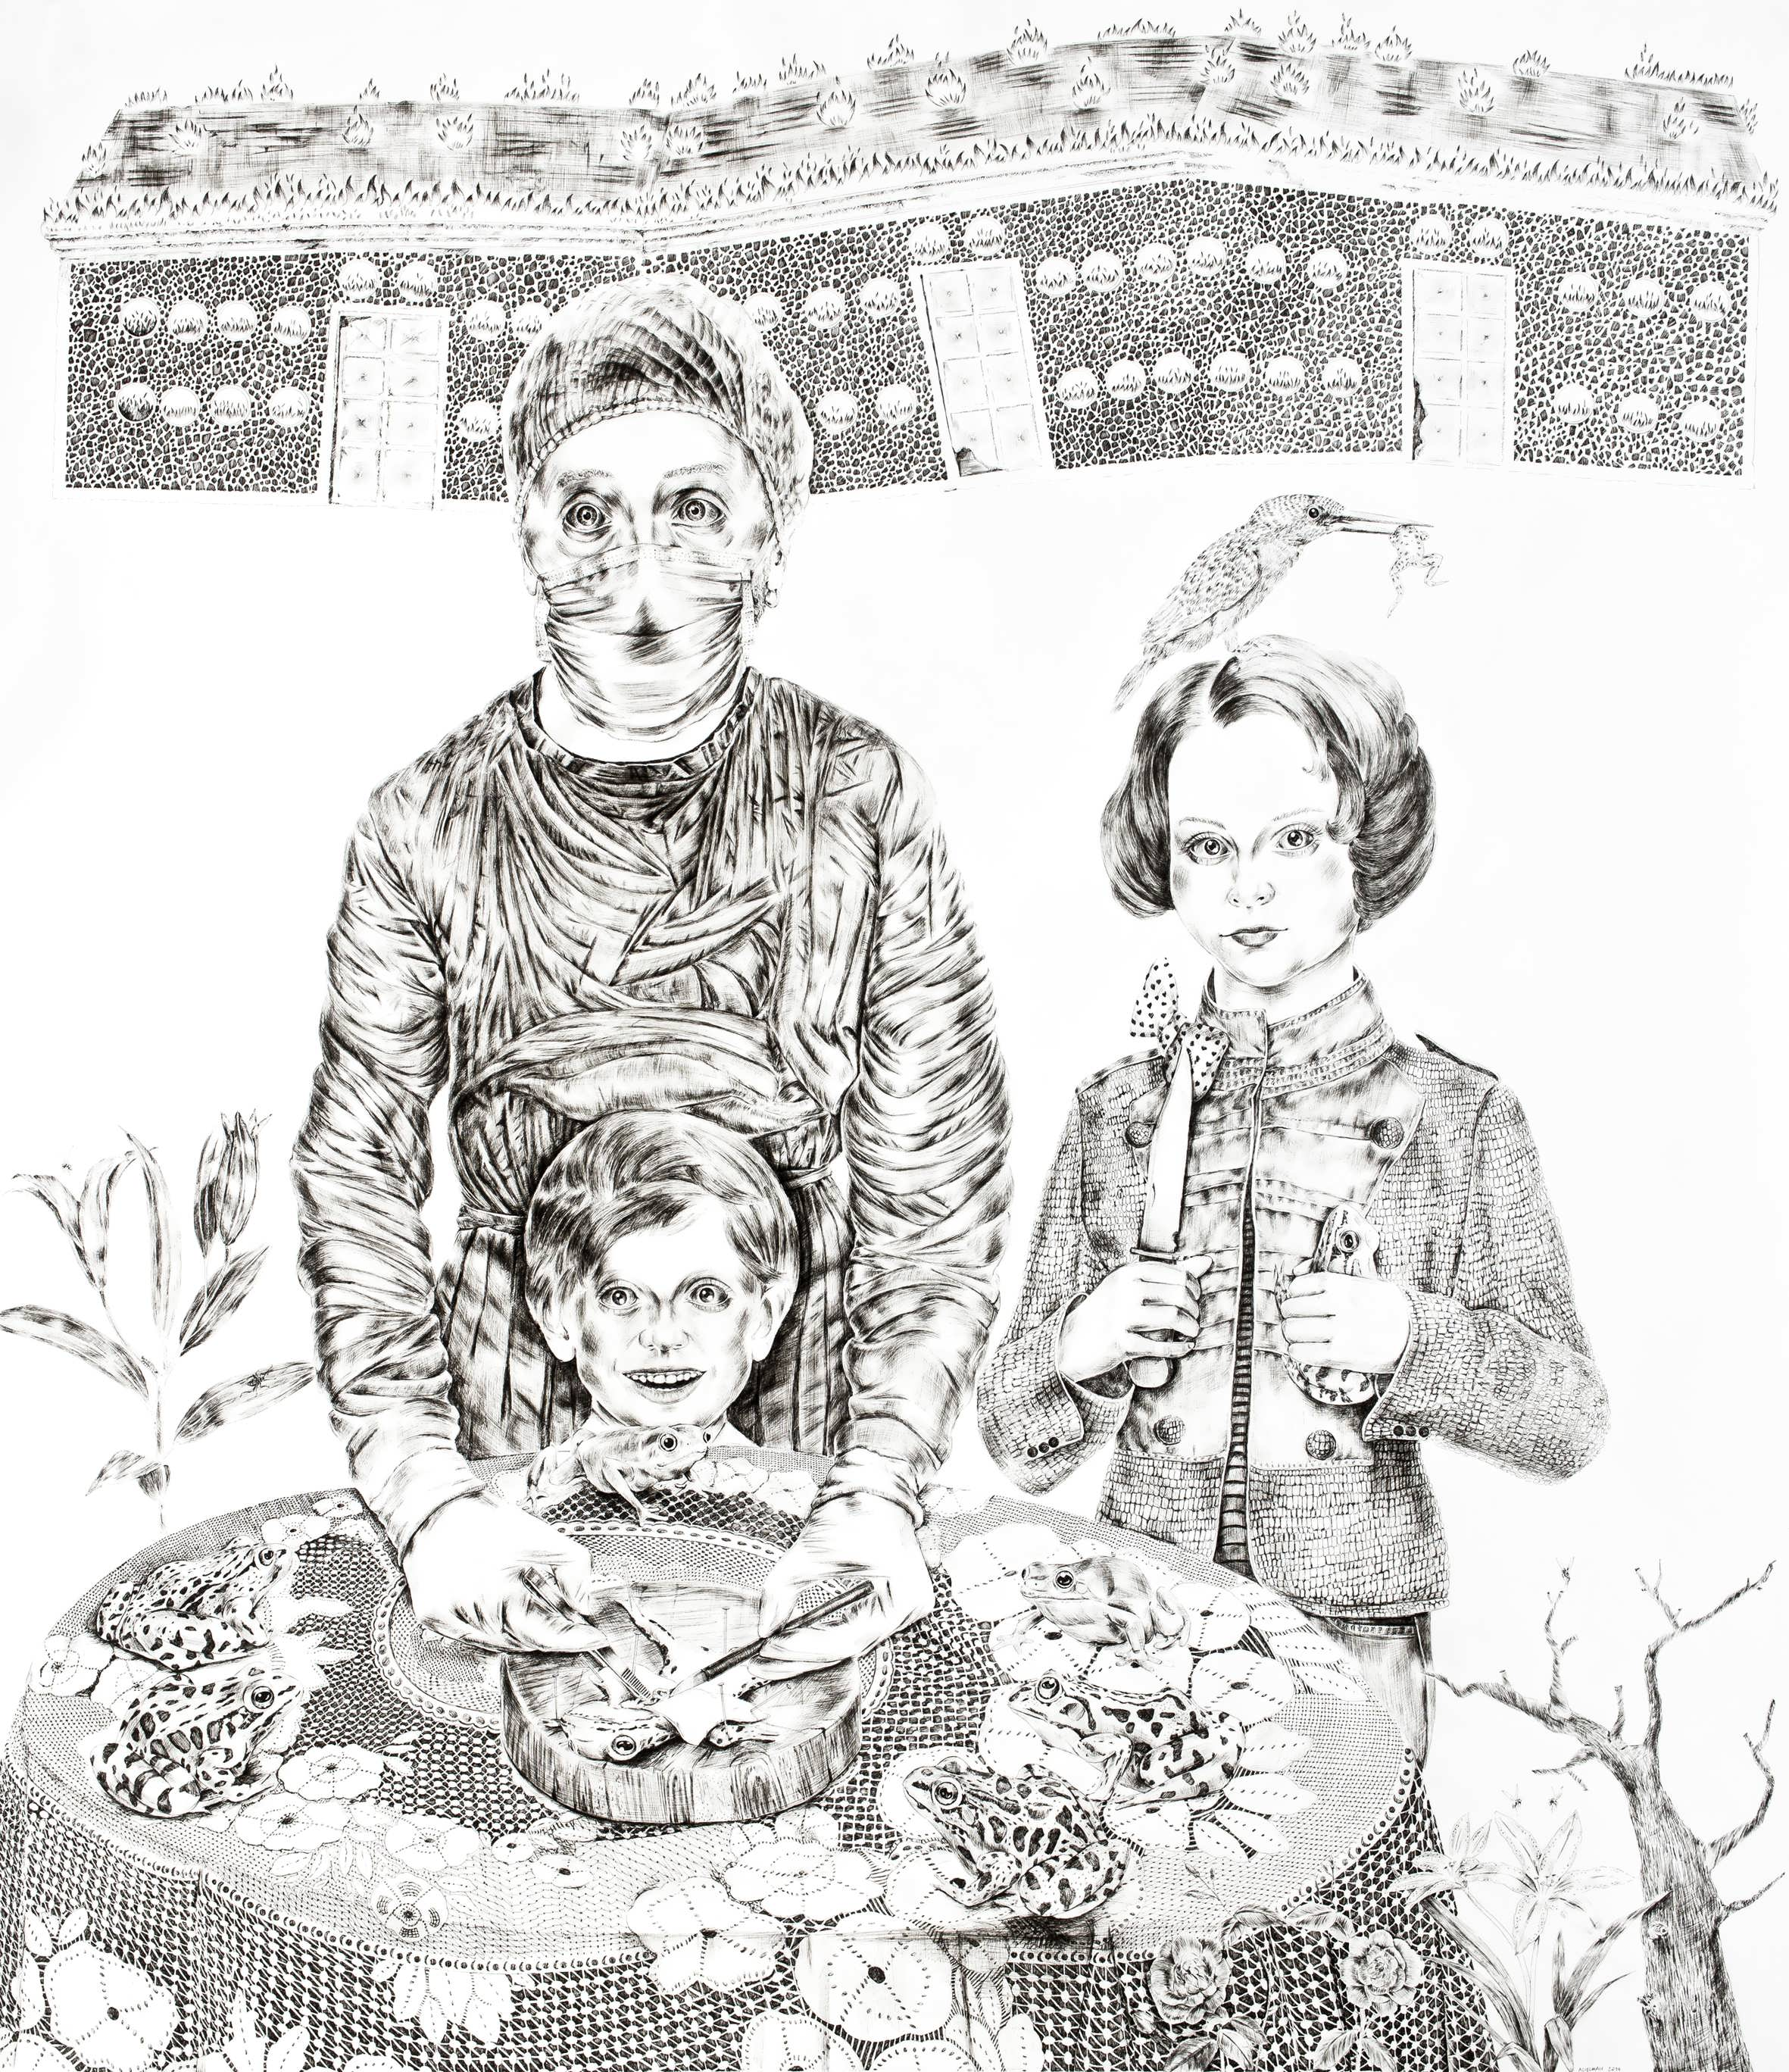

Ali Elmacı, “Make Me Believe in What You Want”, Ink on paper, 160 x 140 cm, 2014

In his unique digital works, Ansen transforms mundane daily objects, composing new narratives, through an interaction of sculpture, photography and painting. His works are firmly grounded in literature, religion and history where he explores war, prohibition, justice and crime issues. The artist examines the stories enriched through the use of various symbols from an ironic standpoint.
Ansen uses historical concepts as a starting point; originally his stories take form through his imagination. His symbolic analysis of the power systems, such as the military and the government, give clues about today’s politics. The order and the disorder within these systems can also be read through his aesthetics.

Ceren Oykut’s meticulous drawings that resemble miniatures, reconstruct social events and contain symbols that refer to the urban life as well as the artist herself. The chaotic scenes allow the viewer to experience the city as an insider as s/he moves through the many layers of Oykut’s drawings, witnessing stories of urban transformation and the resulting immigration as well as the subconscious of an urban resident. Her work have been shown in many shows in Turkey, Germany, Italy, Slovenia, France, Poland, Austria, Ireland, Belgium, Egypt including Lyon Biennale (2009), Istanbul Biennale (2007), Arco Madrid 2013, Art Basel in Hong Kong (2013) and Artissima 2013.

Erkut Terliksiz is an expressionist painter who combines fantasy and personal experience. In fact, each work consists of many indistinct self-portraits and stories buried in various layers, and depicts the artist’s emotional dilemmas. Although the artist camouflages himself with symbols and primitive figures of his inner world, the personal references can be traced through the details. His works, which seem like fiction at first but involve personal tales, are presented to the audience to let their own stories come out. In addition, the artist's recent focus on using experimental material (such as tea bags, wood and cardboard) continues in his proposed work. “Thanks for Sharing” (Leipzig, Germany), “Confessions of Dangerous Minds” (Saatchi Gallery, London) and “Happy Medium” (Nancy Victor Gallery, London) are some of the international shows Terliksiz attended.

The painter Ali Elmacı depicts the modern history of social problems without restraint when it comes to using irony and sarcasm. The aspects of family, society, state, media and sacred values, which are invisible to the naked eye are conveyed through the scenarios and characters that he builds. In his series "You Will Find Me Not Where You're Looking But Where You've Forgotten Me" proposed to Art 14 London, Elmacı shows his mastery in drawing. "You Will Find Me Not Where You're Looking But Where You've Forgotten Me" is a follow-up to his previous work dealing with the media's manipulation of the current events. Elmacı looks at the difference between real occurrences and their camouflaged accounts in the media, claiming that the media cultivates obliviousness in the society by directing its attention from reality to fiction. Elmacı defends through his surreal characters that by making deceptive government propaganda, the media shapes the society and its consumption power in the desired way. With a critical viewpoint, Elmacı aims to confront the viewer with what lies at the bottom of political and social events.

The painter Serkan Adın is another important addition to the x-ist selection. Adin is a successful printmaker - awarded by Bulgaria (11th International Varna Biennial, 2001), Spain (Printmakers, 2002) and Japan (4. KIWA-Kyoto International Kyoto Woodprint Association, 2003) – who later moved on to painting where he created meticulously detailed photographic based acrylic works. Adin recently developed a new technique where he transforms these paintings onto layers of plexi-glass with the use of a needle to transfer the acrylic. Examples of this brand new series will be shown in London following his fifth solo exhibition at x-ist that took place in December 2013. In Adin’s works, it is possible to mention an eye that spreads to the space of the picture and to tell a lot of things about it: a culture that materializes the femininity, but also capitalize on it, a patriarchal culture that describes women only through the norms it specified, a religious culture that is afraid of women and takes guard against them in result of this fear…

Burçin Başar, a young talent recently discovered, brings together reality and fantasy in her work that stems from the undetected realms of consciousness. The traces of a sunken city, an obscure figure reflected on the moss, a few belongings left outdoors… In the scenes of Başar, which look peaceful at first glance, there are mysterious details hidden, while among the nature, which looks as if it is going to spurt out from the canvas, there are signs of life. In this fantastic world that signals the existence of human presence, everything (the heavens and the earth, fact and fantasy, indoors and outdoors) is intertwined; they exist within a structure where they both camouflage and complete each other. We witness the fantastic world perceived by Başar who portrays all contrasts with great harmony.

Originally known as a caricaturist, Bahadır Baruter have proved his mastery in drawing and painting with his previous shows “Existence Anxiety” (2006) and “Your Family is A Lie, Dear” (2012) at x-ist. With a humorous approach, Baruter questions taboos or mundane scenes from everyday life that are not very often subjected to challenge. He deals with the concept of family, religion, money, everything that forms a person’s life as a given or a goal. Baruter recently started working on his new project titled “Why Does God Allow Evil?” - this time dealing with the subconscious of businessmen who are crushed under the weight of their responsibility and certain rituals. His brand new pieces from this series can be seen at Art 14 London.

